Spring Boot poate fi configurat in application.properties

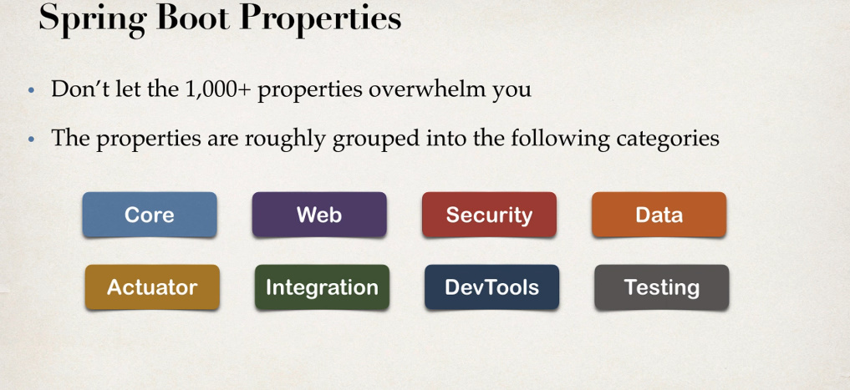

**Core Properties**

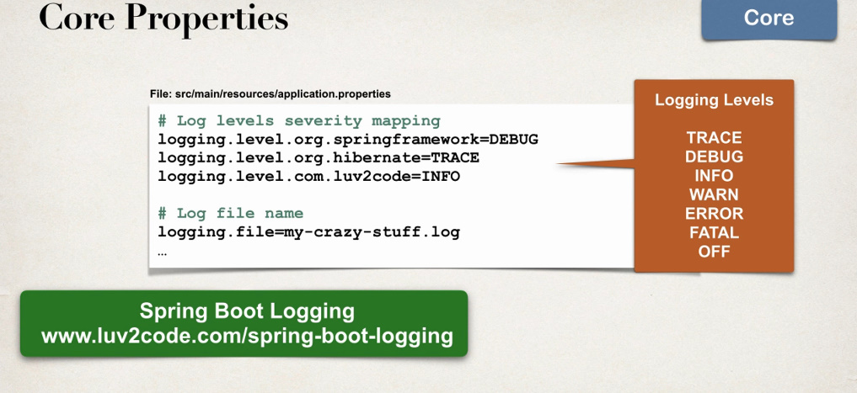

logging.level.classpath – seteaza un loggin level pentru un intreg package

loggin.file – inregitreaza toate logurile intr-un fisier

Spring Boot foloseste Logback!!!

* Pentru a adauga logurile intr-un anumite folder, folosim:
* logging.file.name=${logging.file.path}logFile.log  
  logging.file.path=C:/Users/user/Desktop/demo/src/main/resources/logs/

**Web Properties**

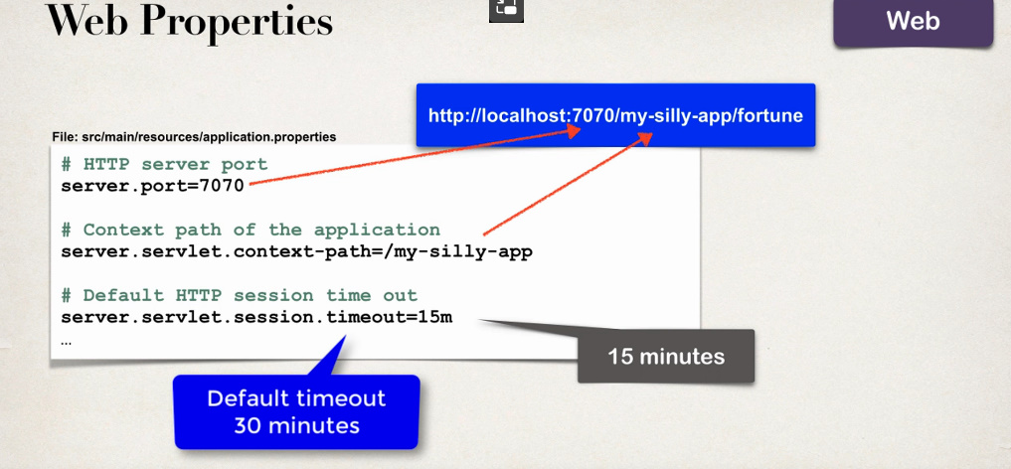

**Actuator Properties**

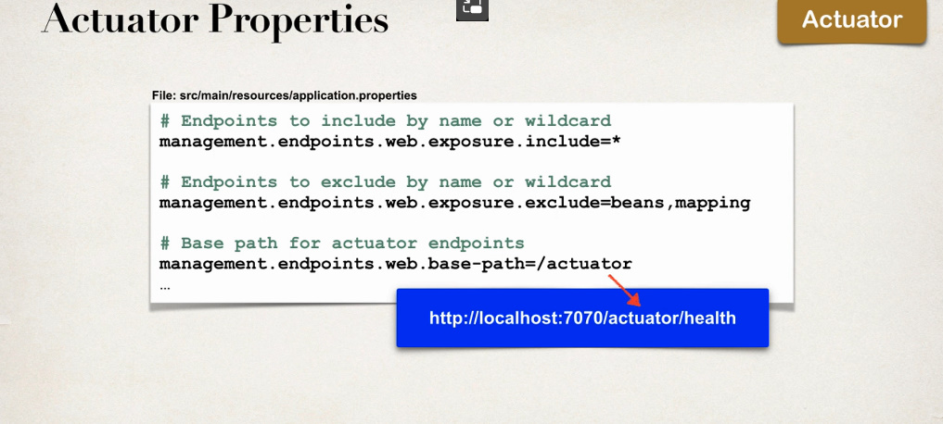

**Security Properties**

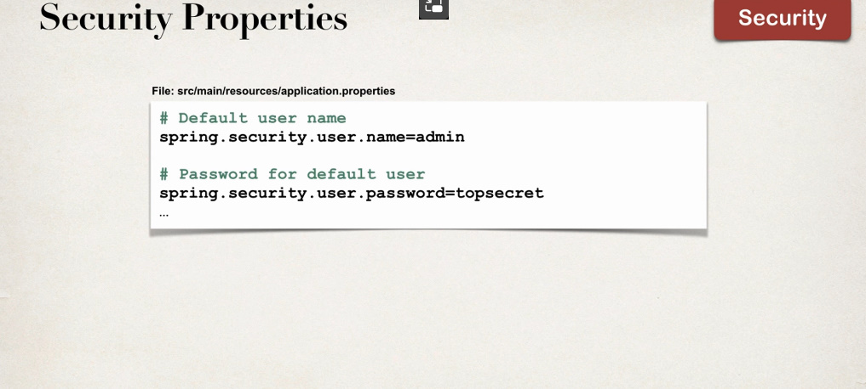

**Data Properties**

